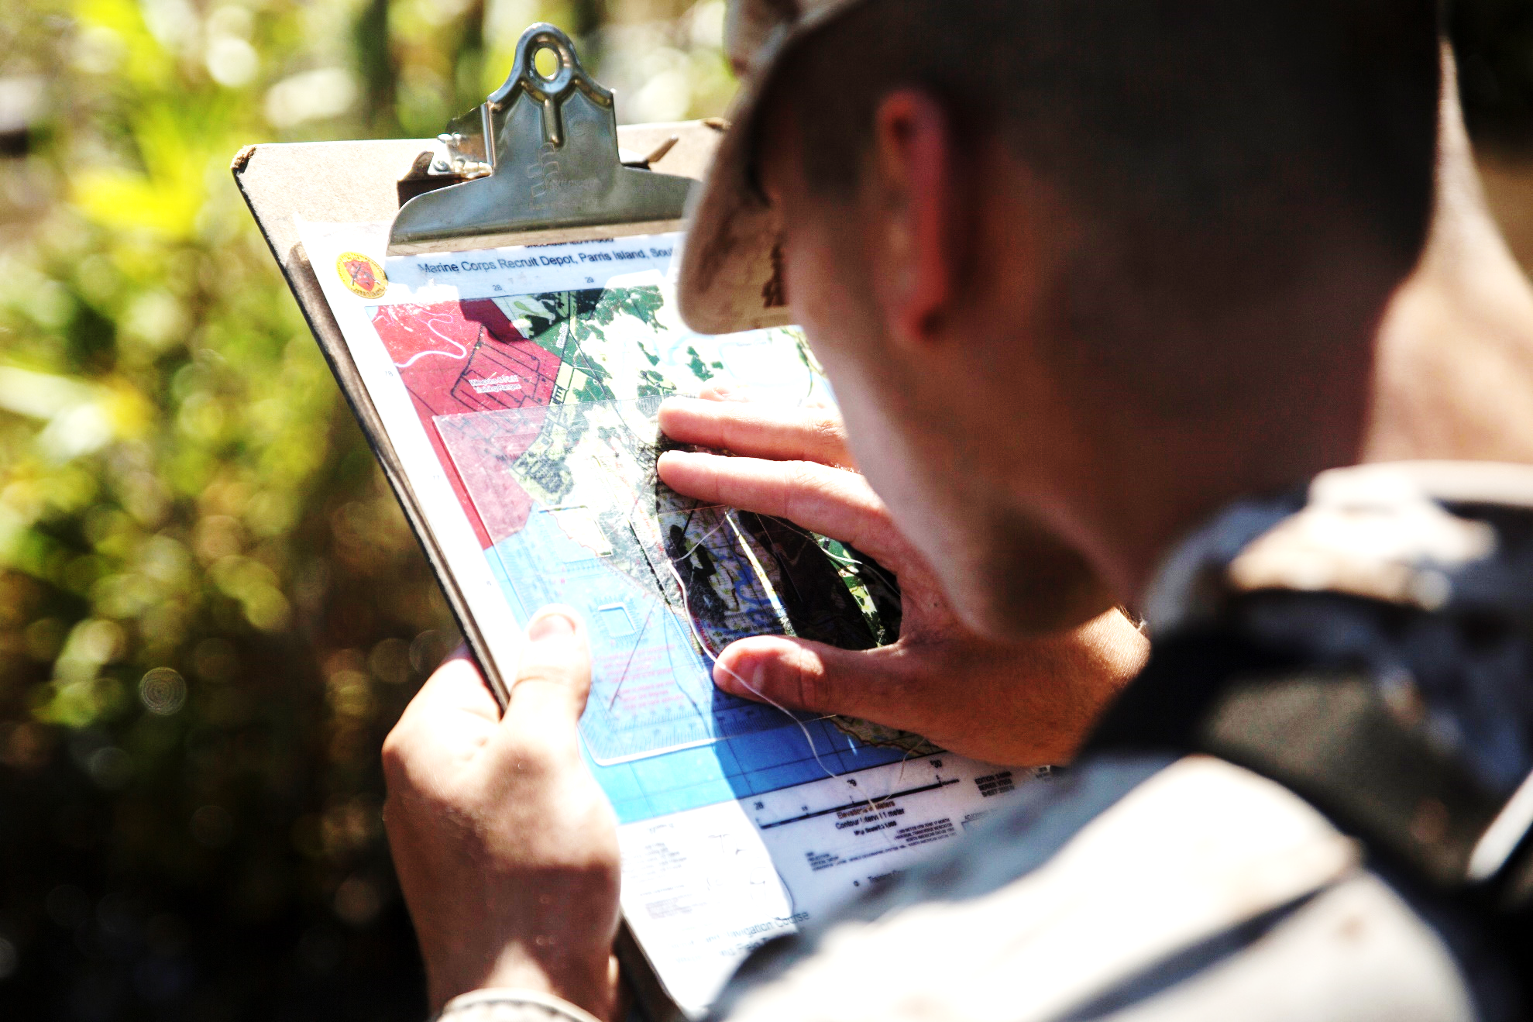

Foundational Values

The values Marines choose to live by will directly impact their choices and actions, and the character they display on and off duty.

Spiritual Fitness

**The accuracy of values printed on a map will greatly affect the outcome of navigation. What are the values you have personally chosen to guide your life?**