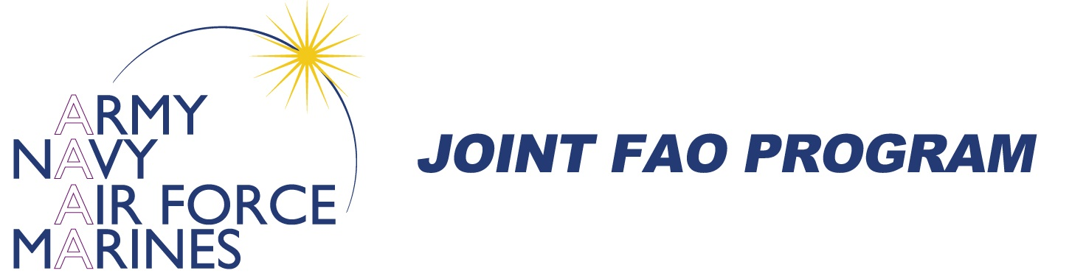
JOINT FAO PROGRAM COURSE REGISTRATION
COURSE NAME: ________________________ ___
LOCATION: ________ _____ DATES: __________________

REQUIREMENTS:
Applicants must be designated as a Foreign Area Officer (USA, USN, USMC, USCG, and USAF) at the level of O5 or O6, with exceptions possible for O3s/O4s who have completed a significant FAO tour.
Please note the Service Member is responsible for identifying any funding required to attend this course.

INSTRUCTIONS:
Please complete this form in its entirety. Send this along with your BIO w/Photo to your proponent office and to DLNSEO, Ms. Beverly Rouse @ beverly.p.rouse.civ@mail.mil

Applicant Information
Last Name |  | First Name |  | M.I.
Service |  | Rank
Full Title |  | Unit Title
Primary  E-Mail |  | Primary  Phone
Personal
E-Mail (Readings)
Primary MOS |  | FAO Regional Specialty
 | Course reading materials will be provided through access to the FAOs personal email address. Course completion certificates will be provided to the FAOs official email address

 |  | Education
 |  | Undergraduate Institution |  |  |  | Degree |  |  |  | Year
 |  | Graduate Institution |  |  |  | Degree |  |  |  | Year
 |  | Other Institution |  |  |  | Degree |  |  |  | Year
Languages/
Skill Levels

FAO ASSIGNMENTS
 | From - To |  | Location |  |  |  | Position

Previous JFAO Training **Please annotate if training was requested, but not received**
From - To | Location | Position

