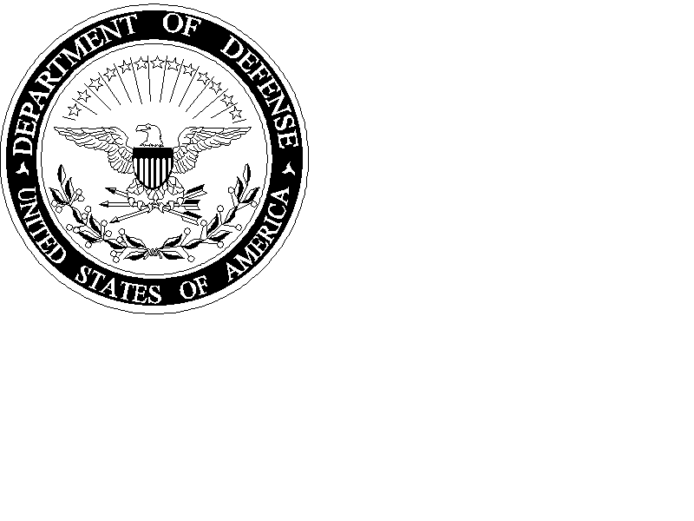UNITED STATES MARINE CORPS
MARINE CORPS SECURITY COOPERATION GROUP
U.S. MARINE CORPS FORCES COMMAND
JEBLC-FORT STORY, VIRGINIA 23459-0007
IN REPLY REFER TO:
1520
17 Jan 2013

From: Major Paul Sotomayor, MARFORNORTH Coordination, Liaison
and Assessment Team
To: International Affairs Program Coordinator (PLU-8)

Subj: AFTER ACTION REPORT, MEXICAN MARINES JUNIOR OFFICER
DEVELOPMENT COURSE

Background: The Marine Forces North Junior Officer Development Course (JODC) is a key event in the professional development line of operation for the Mexican Marine Corps (MEXMAR). The JODC 2012 event provided 87 junior MEXMAR officers an introduction to the U.S. Marine Corps and training focused on weapons employment and combat leadership skills. It occurred aboard Marine Corps Recruit Depot (MCRD) San Diego and Camp Pendleton, CA from 26 November to 15 December, 2012. The training package was oriented on individual combat skills and fitness, military operations in urban terrain (MOUT), machine gunnery, individual marksmanship, combat lifesaving skills, and martial arts. Many units supported the JODC in a variety of roles. The Marine Corps Security Cooperation Group (MCSCG) assisted the development, planning, coordination and execution of the event, in concert with Marine Forces North (MARFORNORTH), and the Office of Defense Cooperation (ODC) Mexico City. MCRD San Diego, Recruit Training Regiment and Weapons Field Training Battalion provided significant logistical support as well as an introduction to recruit training, rifle marksmanship and opportunities to participate in parts of the Crucible. I MEF and 1st Marine Division offered significant support as well. The Division provided MOUT training and portions of the machine gunnery instruction while the MEF assisted in logistical support. A crucial enabler to the success of the JODC was the mentorship team sourced from I MEF. Eight officers and Staff Non-Commissioned Officers (SNCO) from diverse experiences and specialties participated in the entire JODC to foster relationships with the MEXMAR officers. The effort was enriching for all Marines, Mexican and American.

Topic: FAOs in the JODC

Discussion: Four Latin America Foreign Area Officers (FAOs) played crucial roles in the success of this event. LtCol William Fearn coordinated efforts from ODC Mexico City. Maj Paul Sotomayor, Capt Armando Daviu, and Capt Callon Nichols were instrumental to MCSCG efforts in planning and execution. FAOs ensured MEXMAR objectives and goals were incorporated from the developmental stages of planning through JODC execution. FAOs provided liaison to I MEF and MCRD staff in order to ensure security cooperation activities were aligned with MARFORNORTH end state objectives. FAOs consistently engaged with senior MEXMAR officers on a daily basis, providing progress updates on training events and feedback on MEXMAR officer development goals. FAOs worked closely with I MEF Marines who participated as event mentors and embedded with MEXMAR squads during training, providing language translation and facilitating cultural exchange. The sum of this training forged lasting relationships and a cultural bridge between junior MEXMAR officers and U.S. Marines. FAOs coordinated with Combat Camera to ensure the cross-cultural interaction was captured and documented, per MARFORNORTH PAO guidance. FAOs performed as mentors between instructors from all units, providing language and cultural support. FAOs applied their PMOS in the development and execution of several courses of instruction while translating material for others. FAOs accompanied senior MEXMAR officers during MEXMAR briefs to MCRD officers and SNCOs, while facilitating discussion, question and answer periods. FAOs coordinated and escorted all 87 MEXMAR to cultural events in San Diego, including a visit to USS Midway.

Recommendation: Language, regional expertise and culture (LREC) skills, mixed with credibility in PMOS skill sets, made FAOs extremely valuable to all organizations who participated in this security cooperation event. Spanish language alone was often not enough to get the job done. Documents cannot be effectively translated word for word, using tools like Google translate. All events and briefs were translated in real time, from Spanish to English, and English to Spanish, often interpreting messages and anecdotes that needed to be conveyed carefully. Understanding issues unique to Mexico was needed to build strong bridges with our proud MEXMAR partners. Engagement of regional specialists to accomplish operational requirements is a key to successful security cooperation planning and execution.

Summary: Mexico is a priority country to NORTHCOM. The ability to build partner capacity is specifically called for in National Security Strategy and National Military Strategy. The JODC efforts to develop stronger relationships with MEXMAR were a big success. MARFORNORTH and MCSCG are committed to further professionalization of the MEXMAR force and improvement of USMC-MEXMAR relationships. FAOs played a significant role throughout the process.

Respectfully Submitted,
Major Paul Sotomayor

